Lab Taks-2

Question- 1

Draw a Rainbow Flag

Graph Plot (Picture)-
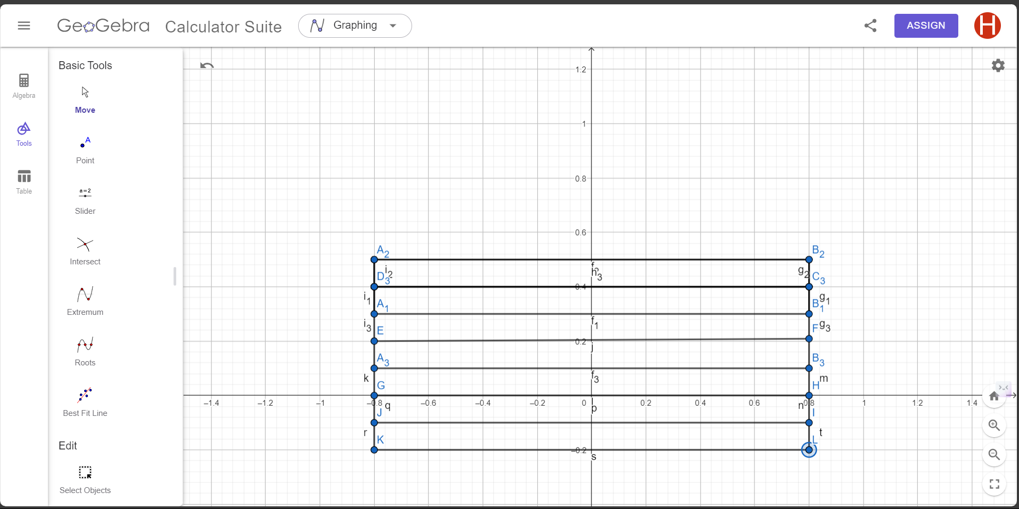

Code-

#include <windows.h>
#include <GL/glut.h>
void initGL() {

glClearColor(1.0f, 1.0f, 1.0f, 1.0f);

}

void display() {
glClear(GL_COLOR_BUFFER_BIT);
glClearColor(1.0f, 1.0f, 1.0f, 1.0f);

glBegin(GL_POLYGON);

glColor3f(0.4f, 0.0f, 0.8f);

glVertex2f(-0.8f, 0.5f);
glVertex2f(0.8f, 0.5f);

glVertex2f(0.8f, 0.5f);
glVertex2f(0.8f, 0.4f);

glVertex2f(0.8f, 0.4f);
glVertex2f(-0.8f, 0.4f);

glVertex2f(-0.8f, 0.4f);
glVertex2f(-0.8f, 0.5f);

glEnd();

glBegin(GL_POLYGON);

glColor3f(0.0f, 0.0f, 1.0f);

glVertex2f(-0.8f, 0.4f);
glVertex2f(0.8f, 0.4f);

glVertex2f(0.8f, 0.4f);
glVertex2f(0.8f, 0.3f);

glVertex2f(0.8f, 0.3f);
glVertex2f(-0.8f, 0.3f);

glVertex2f(-0.8f, 0.3f);
glVertex2f(-0.8f, 0.4f);

glEnd();

glBegin(GL_POLYGON);

glColor3f(0.2f, 1.0f, 1.0f);

glVertex2f(-0.8f, 0.3f);
glVertex2f(0.8f, 0.3f);

glVertex2f(0.8f, 0.3f);
glVertex2f(0.8f, 0.2f);

glVertex2f(0.8f, 0.2f);
glVertex2f(-0.8f, 0.2f);

glVertex2f(-0.8f, 0.2f);
glVertex2f(-0.8f, 0.3f);

glEnd();

glBegin(GL_POLYGON);

glColor3f(0.0f, 0.6f, 0.0f);

glVertex2f(-0.8f, 0.2f);
glVertex2f(0.8f, 0.2f);

glVertex2f(0.8f, 0.2f);
glVertex2f(0.8f, 0.1f);

glVertex2f(0.8f, 0.1f);
glVertex2f(-0.8f, 0.1f);

glVertex2f(-0.8f, 0.1f);
glVertex2f(-0.8f, 0.2f);

glEnd();

glBegin(GL_POLYGON);

glColor3f(1.0f, 0.5f, 0.0f);

glVertex2f(-0.8f, 0.1f);
glVertex2f(0.8f, 0.1f);

glVertex2f(0.8f, 0.1f);
glVertex2f(0.8f, 0.0f);

glVertex2f(0.8f, 0.0f);
glVertex2f(-0.8f, 0.0f);

glVertex2f(-0.8f, 0.0f);
glVertex2f(-0.8f, 0.1f);

glEnd();
glBegin(GL_POLYGON);

glColor4f(1.0f, 1.0f, 0.0f, 0.0f);

glVertex2f(-0.8f, 0.0f);
glVertex2f(0.8f, 0.0f);

glVertex2f(0.8f, 0.0f);
glVertex2f(0.8f, -0.1f);

glVertex2f(0.8f, -0.1f);
glVertex2f(-0.8f, -0.1f);

glVertex2f(-0.8f, -0.1f);
glVertex2f(-0.8f, 0.0f);

glEnd();

glBegin(GL_POLYGON);

glColor3f(1.0f, 0.0f, 0.0f);

glVertex2f(-0.8f, -0.1f);
glVertex2f(0.8f, -0.1f);

glVertex2f(0.8f, -0.1f);
glVertex2f(0.8f, -0.2f);

glVertex2f(0.8f, -0.2f);
glVertex2f(-0.8f, -0.2f);

glVertex2f(-0.8f, -0.2f);
glVertex2f(-0.8f, -0.1f);

glEnd();
glFlush();

}

/* Main function: GLUT runs as a console application starting at main() */

int main(int argc, char** argv) {

glutInit(&argc, argv); // Initialize GLUT

glutCreateWindow("Vertex, Primitive & Color"); // Create window with the given title

glutInitWindowSize(5000, 4000); // Set the window's initial width & height

glutDisplayFunc(display); // Register callback handler for window re-paint event

initGL(); // Our own OpenGL initialization

glutMainLoop(); // Enter the event-processing loop

return 0;

}

Output Screenshot (Full Screen)-
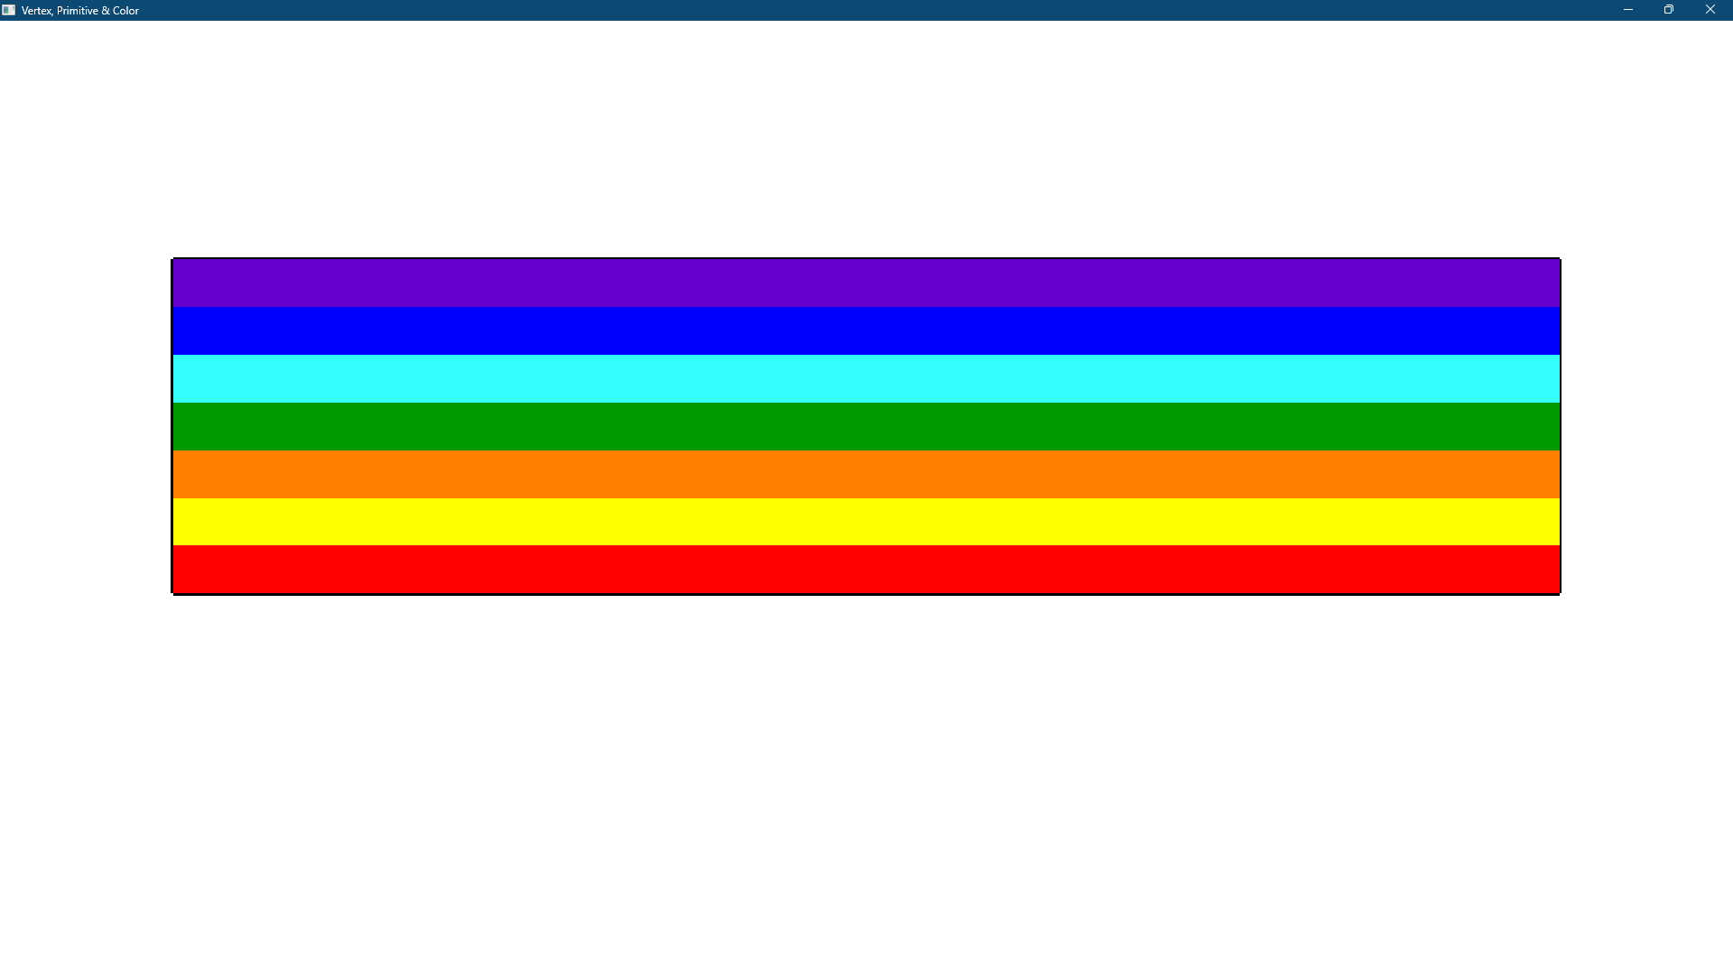

Question- 2

Draw 4X4 Chess Board

Graph Plot (Picture)-

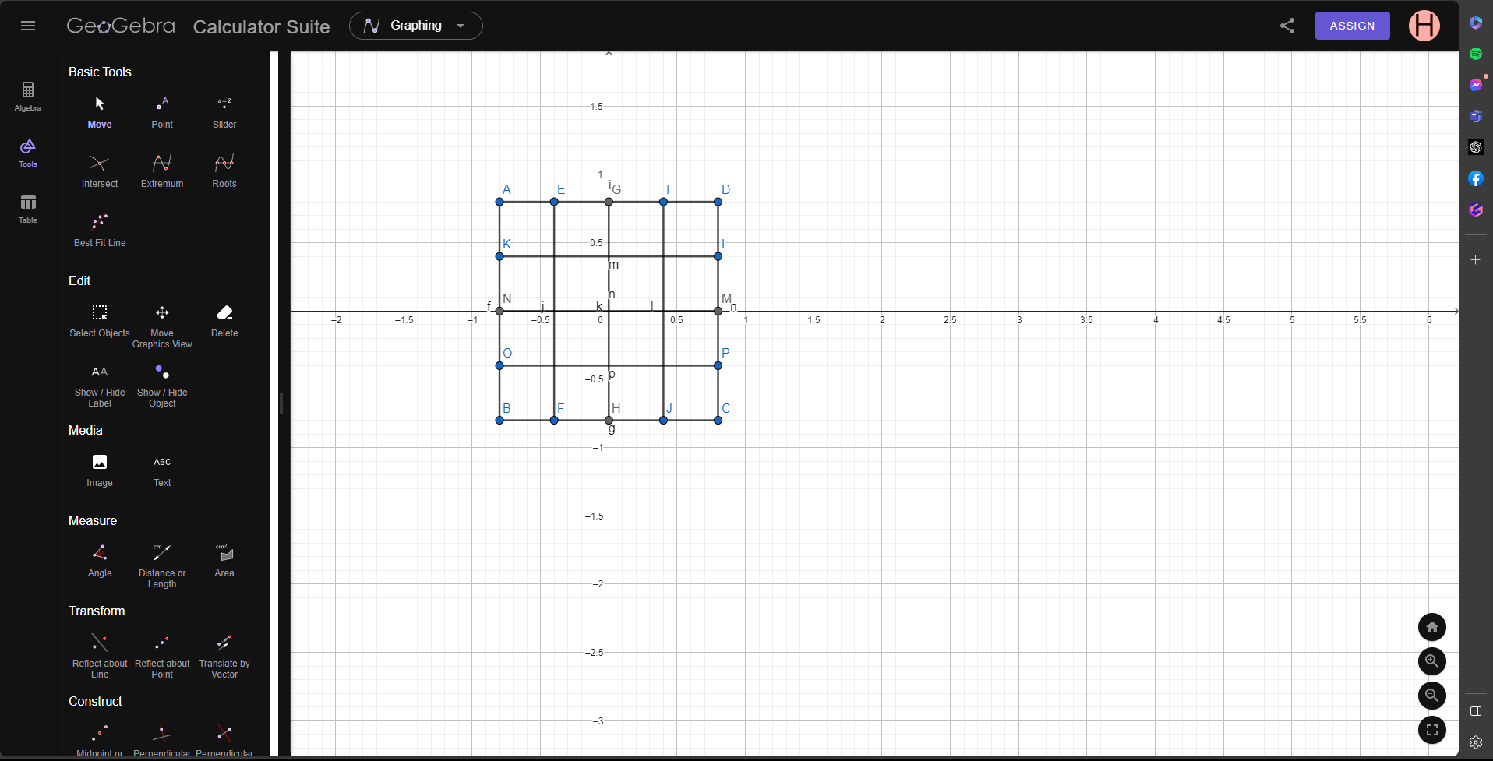
Code-
#include <windows.h>
#include <GL/glut.h>

void display() {

glClearColor(1.0f, 1.0f, 1.0f, 1.0f);

glClear(GL_COLOR_BUFFER_BIT);

glLineWidth(5);

glBegin(GL_LINES);

glColor3f(0.0f, 0.0f, 0.0f);
//block
glVertex2f(-0.8, 0.8);
glVertex2f(-0.8, -0.8);

glVertex2f(-0.8, -0.8);
glVertex2f(0.8, -0.8);

glVertex2f(0.8, -0.8);
glVertex2f(0.8, 0.8);

glVertex2f(0.8, 0.8);
glVertex2f(-0.8, 0.8);
//up line
glVertex2f(-.4f, .8f);
glVertex2f(-.4f, -.8f);

glVertex2f(0.0f, .8f);
glVertex2f(0.0f, -.8f);

glVertex2f(.4f, .8f);
glVertex2f(.4f, -.8f);
//low line

glVertex2f(-.8f, .4f);
glVertex2f(0.8f, .4f);

glVertex2f(-.8f, 0.0f);
glVertex2f(.8f, 0.0f);

glVertex2f(-.8f, -.4f);
glVertex2f(.8f, -.4f);

glEnd();

glBegin(GL_POLYGON);
glColor3f(0.0f, 0.0f, 0.0f);
glVertex2f(-0.8, 0.8);
glVertex2f(-0.8, 0.4);

glVertex2f(-0.8, 0.4);
glVertex2f(-0.4, 0.4);

glVertex2f(-0.4, 0.4);
glVertex2f(-0.4, 0.8);

glVertex2f(-0.4, 0.8);
glVertex2f(-0.8, 0.8);

glEnd();

glBegin(GL_POLYGON);
glColor3f(0.0f, 0.0f, 0.0f);
glVertex2f(-0.8, 0);
glVertex2f(-0.8, -0.4);

glVertex2f(-0.8, -0.4);
glVertex2f(-0.4, -0.4);

glVertex2f(-0.4, -0.4);
glVertex2f(-0.4, 0);

glVertex2f(-0.4, 0);
glVertex2f(-0.8, 0);

glEnd();

glBegin(GL_POLYGON);
glColor3f(0.0f, 0.0f, 0.0f);
glVertex2f(0, 0.8);
glVertex2f(0.4, 0.8);

glVertex2f(0.4, 0.8);
glVertex2f(0.4, 0.4);

glVertex2f(0.4, 0.4);
glVertex2f(0, 0.4);

glVertex2f(0, 0.4);
glVertex2f(0, 0.8);

glEnd();

glBegin(GL_POLYGON);
glColor3f(0.0f, 0.0f, 0.0f);
glVertex2f(-0.4, 0.4);
glVertex2f(0, 0.4);

glVertex2f(0, 0.4);
glVertex2f(0, 0);

glVertex2f(0, 0);
glVertex2f(-0.4, 0);

glVertex2f(-0.4, 0);
glVertex2f(-0.4, 0.4);

glEnd();

glBegin(GL_POLYGON);
glColor3f(0.0f, 0.0f, 0.0f);
glVertex2f(0, 0);
glVertex2f(0.4, 0);

glVertex2f(0.4, 0);
glVertex2f(0.4, -0.4);

glVertex2f(0.4, -0.4);
glVertex2f(0, -0.4);

glVertex2f(0, -0.4);
glVertex2f(0, 0);

glEnd();

glBegin(GL_POLYGON);
glColor3f(0.0f, 0.0f, 0.0f);
glVertex2f(0.4, 0.4);
glVertex2f(0.4, 0);

glVertex2f(0.4, 0);
glVertex2f(0.8, 0);

glVertex2f(0.8, 0);
glVertex2f(0.8, 0.4);

glVertex2f(0.8, 0.4);
glVertex2f(0.4, 0.4);

glEnd();

glBegin(GL_POLYGON);
glColor3f(0.0f, 0.0f, 0.0f);
glVertex2f(-0.4, -0.4);
glVertex2f(-0.4, -0.8);

glVertex2f(-0.4, -0.8);
glVertex2f(0, -0.8);

glVertex2f(0, -0.8);
glVertex2f(0, -0.4);

glVertex2f(0, -0.4);
glVertex2f(-0.4, -0.4);

glEnd();

glBegin(GL_POLYGON);
glColor3f(0.0f, 0.0f, 0.0f);
glVertex2f(0.4, -0.8);
glVertex2f(0.8, -0.8);

glVertex2f(0.8, -0.8);
glVertex2f(0.8, -0.4);

glVertex2f(0.8, -0.4);
glVertex2f(0.4, -0.4);

glVertex2f(0.4, -0.4);
glVertex2f(0.4, -0.8);

glEnd();

glEnd();

glFlush();

}

int main(int argc, char** argv) {

glutInit(&argc, argv);

glutCreateWindow("OpenGL Setup");

glutInitWindowSize(5000, 4000);

glutDisplayFunc(display);
glutMainLoop();

return 0;

}

Output Screenshot (Full Screen)-
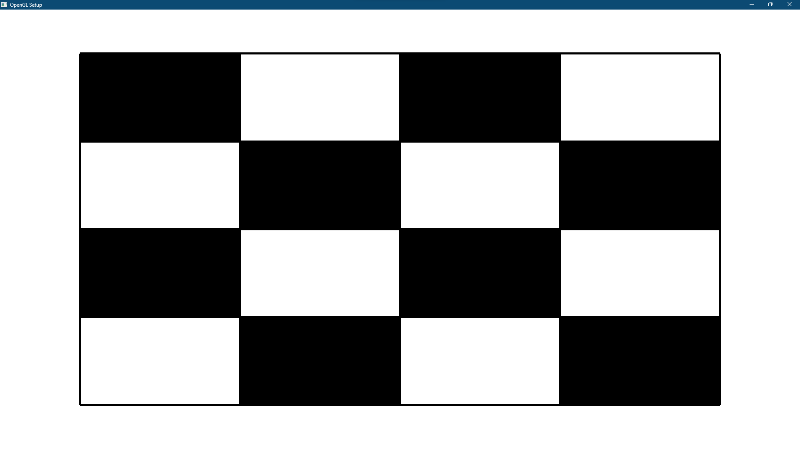

Question- 3

Create the batman logo given below-
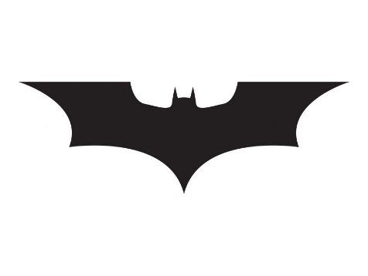

Graph Plot (Picture)-
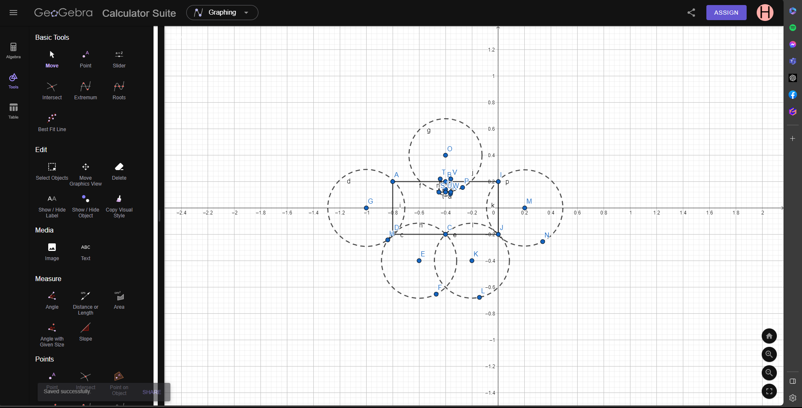

Code-
#include <windows.h>
#include<math.h>
#include <GL/glut.h>

void initGL() {

glClearColor(0.0f, 0.0f, 0.0f, 0.0f);

}

void display() {
glClearColor(1.0f, 1.0f, 1.0f, 1.0f);
glClear(GL_COLOR_BUFFER_BIT);
glLineWidth(7.5);

glBegin(GL_POLYGON);

glColor3f(0.0f, 0.0f, 0.0f);
glVertex2f(-0.8, 0.2);
glVertex2f(-0.8, -0.2);

glVertex2f(-0.8, -0.2);
glVertex2f(0.0f, -0.2f);

glVertex2f(0.0f, -0.2f);
glVertex2f(0.0f, 0.2f);

glVertex2f(0.0f, 0.2f);
glVertex2f(-0.8, 0.2);

glEnd();

glBegin(GL_POLYGON);

float xOffset = -1.0f;
float yOffset = 0.0f;

for (int i = 0; i < 300; i++)
{
glColor3f(1.0f, 1.0f, 1.0f);

float pi = 3.1416;
float a = (i * 2 * pi) / 300;
float r = 0.291996969092;
float x = r * cos(a) + xOffset;
float y = r * sin(a) + yOffset;
glVertex2f(x, y);
}

glEnd();

glBegin(GL_POLYGON);

float xOffse = -0.6f;
float yOffse = -0.4f;

for (int i = 0; i < 300; i++)
{
glColor3f(1.0f, 1.0f, 1.0f);

float pi = 3.1416;
float a = (i * 2 * pi) / 300;
float r = 0.285057846547;
float x = r * cos(a) + xOffse;
float y = r * sin(a) + yOffse;
glVertex2f(x, y);
}

glEnd();
glBegin(GL_POLYGON);

float xOffs = -0.2f;
float yOffs = -0.4f;

for (int i = 0; i < 300; i++)
{
glColor3f(1.0f, 1.0f, 1.0f);

float pi = 3.1416;
float a = (i * 2 * pi) / 300;
float r = 0.284071254425;
float x = r * cos(a) + xOffs;
float y = r * sin(a) + yOffs;
glVertex2f(x, y);
}

glEnd();

glBegin(GL_POLYGON);

float xOff = 0.2f;
float yOff = 0.0f;

for (int i = 0; i < 300; i++)
{
glColor3f(1.0f, 1.0f, 1.0f);

float pi = 3.1416;
float a = (i * 2 * pi) / 300;
float r = 0.289255779865;
float x = r * cos(a) + xOff;
float y = r * sin(a) + yOff;
glVertex2f(x, y);
}

glEnd();

glBegin(GL_POLYGON);

float xOf = -0.4f;
float yOf = 0.4f;

for (int i = 0; i < 300; i++)
{
glColor3f(1.0f, 1.0f, 1.0f);

float pi = 3.1416;
float a = (i * 2 * pi) / 300;
float r = 0.277083694778;
float x = r * cos(a) + xOf;
float y = r * sin(a) + yOf;
glVertex2f(x, y);
}

glEnd();

glBegin(GL_POLYGON);

float xO = -0.4f;
float yO = 0.14f;

for (int i = 0; i < 300; i++)
{
glColor3f(0.0f, 0.0f, 0.0f);

float pi = 3.1416;
float a = (i * 2 * pi) / 300;
float r = 0.0499888160722;
float x = r * cos(a) + xO;
float y = r * sin(a) + yO;
glVertex2f(x, y);
}

glEnd();

glBegin(GL_POLYGON);
glColor3f(0.0f, 0.0f, 0.0f);
glVertex2f(-0.45, 0.12);
glVertex2f(-0.4, 0.12);

glVertex2f(-0.4, 0.12);
glVertex2f(-0.44, 0.22);

glVertex2f(-0.44, 0.22);
glVertex2f(-0.45, 0.12);

glEnd();

glBegin(GL_POLYGON);
glColor3f(0.0f, 0.0f, 0.0f);
glVertex2f(-0.36, 0.22);
glVertex2f(-0.36, 0.12);

glVertex2f(-0.36, 0.12);
glVertex2f(-0.4, 0.12);

glVertex2f(-0.4, 0.12);
glVertex2f(-0.36, 0.22);

glEnd();
glEnd();
glFlush();

}

int main(int argc, char** argv) {

glutInit(&argc, argv);

glutCreateWindow("Vertex, Primitive & Color");

glutInitWindowSize(320, 320);

glutDisplayFunc(display);

initGL();

glutMainLoop();

return 0;

}

Output Screenshot (Full Screen)-

